## **AWS Assignment 9: Configure AWS CLI, SDK and Boto**

### **Configure AWS CLI**

Submit AWS CLI commands for below requirement:

1. Create a S3 Bucket  
     
   
2. Deleting S3 Bucket  
   
3. Listing contents of S3 Bucket  
   
4. Creating a EC2 instance  
   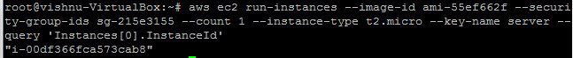  
   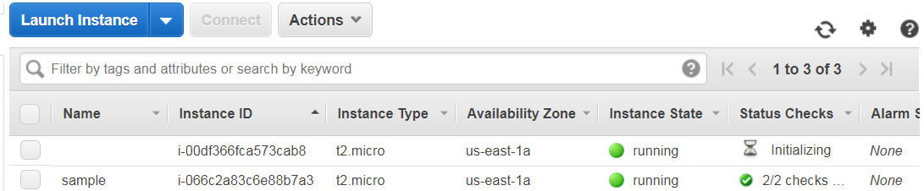
5. Copy a file from local to S3  
     
   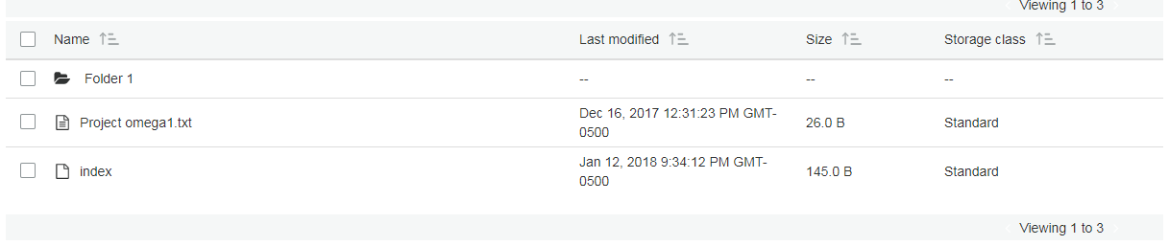
6. Create a RDS instance  
   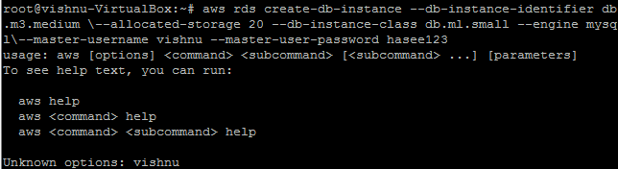
7. Creating a Snapshot for EBS and RDS.  
   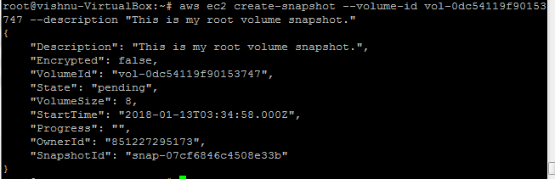
8. Create a IAM user  
   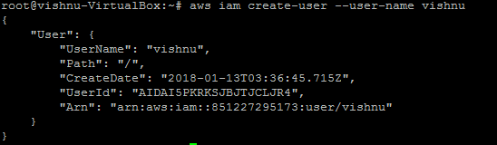  
   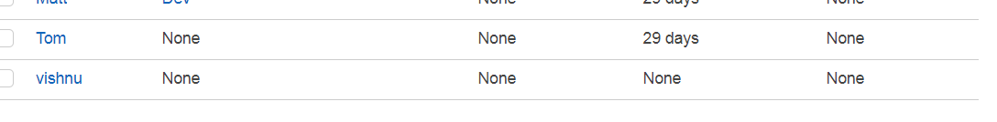
9. Stop/Terminate a EC2 instance  
   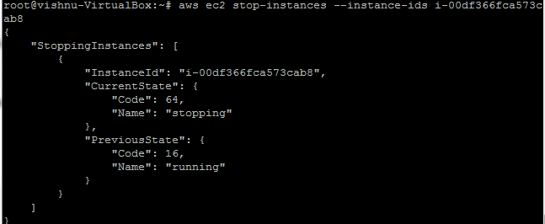  
   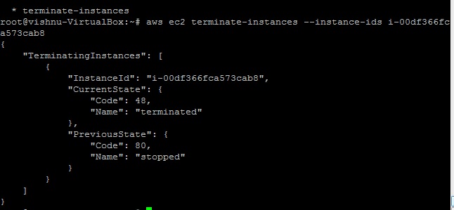
10. Create a EC2 Classic Load Balancer  
    